**Machine Learning**

Branch of Artificial Intelligence that provides systems the ability to automatically learn and improve from experience without being explicitly programmed.

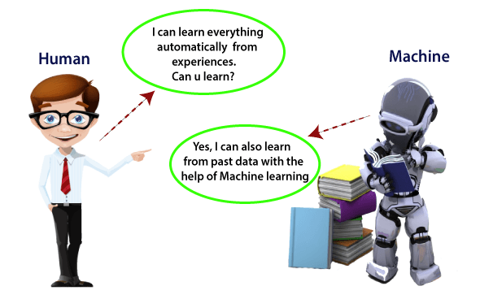

Input Data -> Analyze Data -> Find Pattern -> Prediction -> Store Feedback

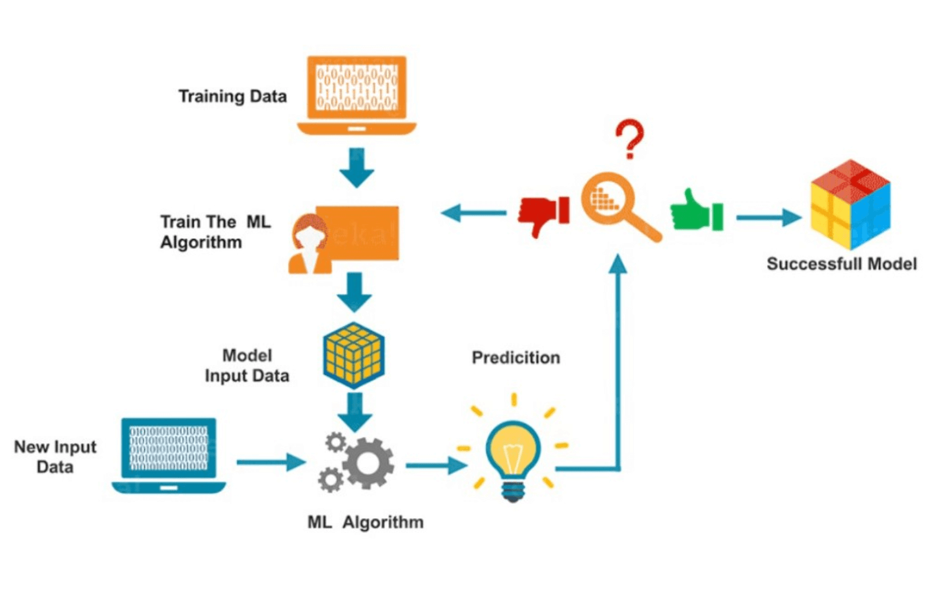

**History**

Discover by Arthur Samuel in 1959, and stated that “it gives computers the ability to learn without being explicitly programmed”.

**Types of Machine Learning**

**1.Supervised Learning**

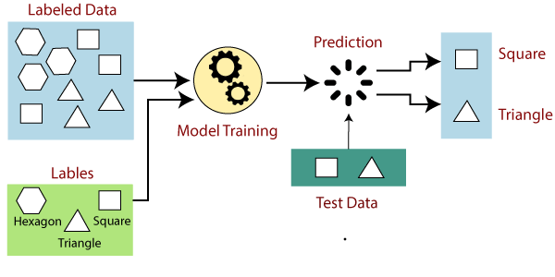

where a computer algorithm is trained on input data that has been labeled for a particular output.

So, model classify data or predict outcomes accurately

**Regression:** Linear regression, Logistic Regression

**Classification:** Naïve Bayes Classifier, Decision Tree, KNN, Support vector machine

**2. Unsupervised Learning**

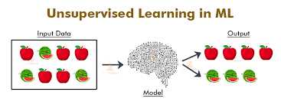

Algorithms has to identify patterns in data sets containing data points that are neither classified nor labeled.

Simply, unsupervised learning allows the system to identify patterns within data sets on its own.

**Clustering:** k-means, hierarchical clustering, Gaussian mixture model

**Dimensionality reduce:** Principal component analysis

**3. Reinforcement Learning**

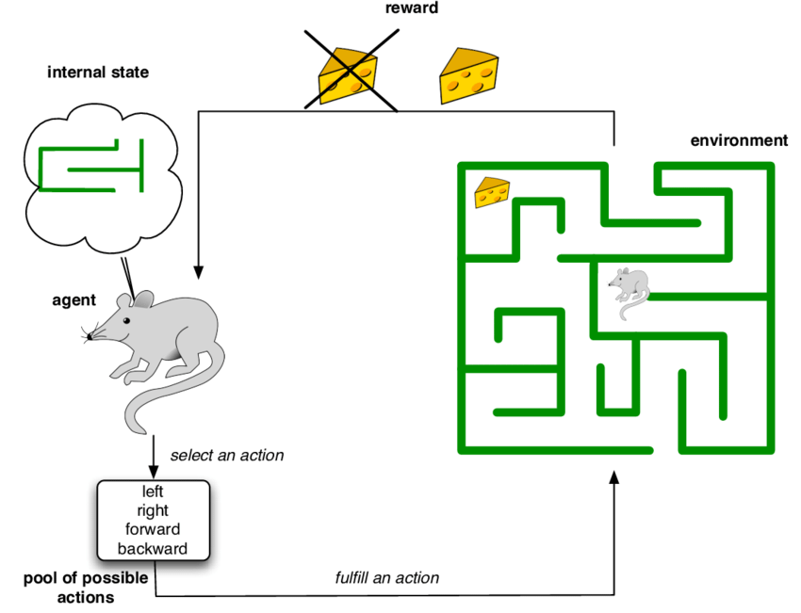

Allow machine or software agent to learn its behavior based on feedback from Envionment.

Learn through trial and error.

**Uses:** Gaming, finance sector, robot navigation.

**Application of ML:**

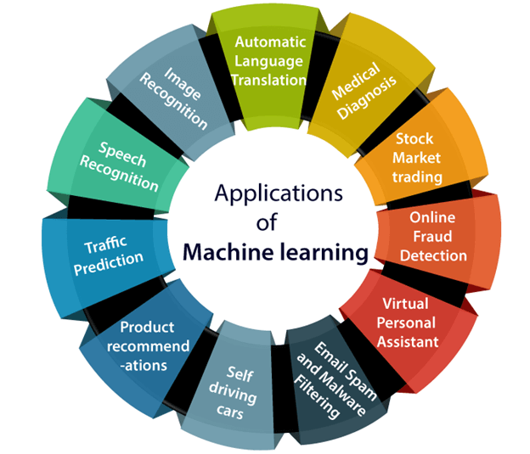

**Machine Learning Workflow**

1. **Get Data**

This process depends on your project and data type.

For example, are you planning to collect real-time data from an IoT system or static data

from an existing database? Or can also use data from internet repositories sites such as

Kaggle and others.

1. **Clean, Prepare & Manipulate Data**

Real-world data often has unorganized, missing, or noisy elements.

This process is a critical step, and people typically spend up to 80% of their time in this stage.

Having a clean data set helps with your model’s accuracy down the road.

1. **Train Model**

Finally, you split your data into training and test data sets.

This step is where the magic happens! The data set connects to an algorithm,

and the algorithm leverages sophisticated mathematical modeling to learn and develop predictions.

1. **Test Model**

Now, it’s time to validate your trained model. Using the test data from Step 3,

we check the model’s accuracy.

1. **Improve**

If the results are not satisfactory after testing data, you need to improve and retrain your ML model

**Advantages of ML**

#### 1. Easily identifies trends and patterns

#### 2. No human intervention needed (automation)

#### 3. Continuous Improvement

#### 4. Handling multi-dimensional and multi-variety data

#### 5. Wide Applications

**Disadvantages of ML**

#### 1. Data Acquisition (Large amount of data to train)

#### 2. Time and Resources

#### 3. Interpretation of Results (algorithm selection)

#### 4. High error-susceptibility